**RAGHUL.V**

**Pizza Sales Analysis**

**(SQL Queries)**

**KPI**

**Total Revenue:**

SELECT SUM(total_price) AS Total_Revenue FROM pizza_sales;

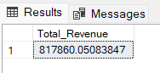

**Average Order Value**

SELECT (SUM(total_price) / COUNT(DISTINCT order_id)) AS Avg_order_Value FROM pizza_sales

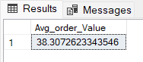

**Total Pizzas Sold**

SELECT SUM(quantity) AS Total_pizza_sold FROM pizza_sales

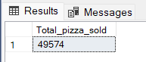

**Total Orders**

SELECT COUNT(DISTINCT order_id) AS Total_Orders FROM pizza_sales

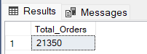

**Average Pizzas per order**

select cast(sum(quantity) as decimal(10,2))/cast(count(distinct order_id) as decimal(10,2)) as average_pizzas_per_order from pizza_sales

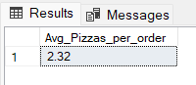

**Daily Trend For Total Orders**

SELECT DATENAME(DW, order_date) AS order_day, COUNT(DISTINCT order_id) AS total_orders

FROM pizza_sales

GROUP BY DATENAME(DW, order_date)

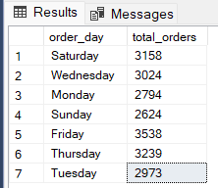

**Monthly Trend For Total Orders**

select DATENAME(MONTH, order_date) as Month_Name, COUNT(DISTINCT order_id) as Total_Orders

from pizza_sales

GROUP BY DATENAME(MONTH, order_date)

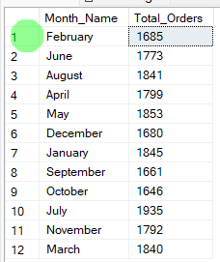

**% Of Sales By Pizza Category**

SELECT pizza_category, CAST(SUM(total_price) AS DECIMAL(10,2)) as total_revenue,

CAST(SUM(total_price) * 100 / (SELECT SUM(total_price) from pizza_sales) AS DECIMAL(10,2)) AS PCT

FROM pizza_sales

GROUP BY pizza_category

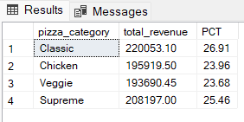

**% Of Pizza Sales By Pizza Size**

SELECT pizza_size, CAST(SUM(total_price) AS DECIMAL(10,2)) as total_revenue,

CAST(SUM(total_price) * 100 / (SELECT SUM(total_price) from pizza_sales) AS DECIMAL(10,2)) AS PCT

FROM pizza_sales

GROUP BY pizza_size

ORDER BY pizza_size

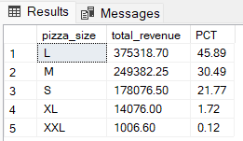

**Total Pizzas Sold By Category**

select pizza_category,sum(quantity) as total_sales from pizza_sales group by pizza_category

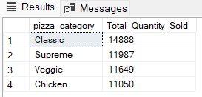

**Top 5 Pizzas By Revenue**

SELECT Top 5 pizza_name, SUM(total_price) AS Total_Revenue

FROM pizza_sales

GROUP BY pizza_name

ORDER BY Total_Revenue DESC

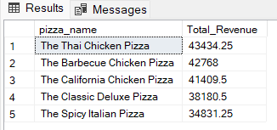

**Bottom 5 Pizzas By Revenue**

SELECT Top 5 pizza_name, SUM(total_price) AS Total_Revenue

FROM pizza_sales

GROUP BY pizza_name

ORDER BY Total_Revenue ASC

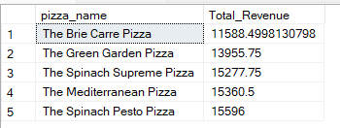

**Top 5 Pizzas By Quantity**

SELECT Top 5 pizza_name, SUM(quantity) AS Total_Pizza_Sold

FROM pizza_sales

GROUP BY pizza_name

ORDER BY Total_Pizza_Sold DESC

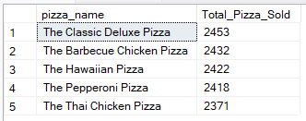

**Bottom 5 Pizzas By Quantity**

SELECT TOP 5 pizza_name, SUM(quantity) AS Total_Pizza_Sold

FROM pizza_sales

GROUP BY pizza_name

ORDER BY Total_Pizza_Sold ASC

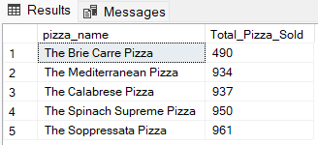

**Top 5 Pizzas By Order**

SELECT Top 5 pizza_name, COUNT(DISTINCT order_id) AS Total_Orders

FROM pizza_sales

GROUP BY pizza_name

ORDER BY Total_Orders DESC

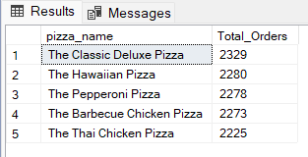

**Bottom 5 Pizzas By Order**

SELECT Top 5 pizza_name, COUNT(DISTINCT order_id) AS Total_Orders

FROM pizza_sales

GROUP BY pizza_name

ORDER BY Total_Orders ASC

